The UN Oil-For-Food Scandal

This article appeared in the 2005 Annual Forecast issue of Dell Horoscope magazine. It was written in the spring of 2004 and accurately predicted the UN oil-for-food scandal

A Change at the Top of the UN?

The April 8 eclipse is on the birthday of UN chief Kofi Annan (April 8, 1938). A solar eclipse on the birthday promises a fated year that is out of one’s control. Two ladies had such birthday eclipses and both moved and married in these eclipsed years. His natal Sun is conjunct Hades. The eclipse here will bring to the surface some unpleasant matters.
The October solar eclipse opposes his Saturn. He was the administrator of the corrupt Iraqi oil-for-food program that was misused to bribe Saddam supporters such as the weapons investigators in the office of Hans Blix. Hopefully, Annan will be held accountable. The chart of the UN has the Sun at 5 Taurus, a degree that will be bracketed by the lunar eclipses in that axis, eventually to be squared by Saturn. The progressed Sun of the UN is at 21 Gemini, getting hit by Pluto-Hades. He was sworn in on December 17, 1996 with Mars at 24 Virgo square the Sun at 26 Sagittarius. Pluto and Hades are advancing into this axis. It does not appear that this bird will fall from his perch, but he is in for a fight.

September 1, 2005 Postscript:

The scandal is now well-known. Many in Europe and in the UN were being paid off by Saddam Hussein to help Iraq evade the trade sanctions. Below we see Annan’s chart surrounded by the April eclipse horoscope. Keep in mind that the Saturn station was at 20 Cancer on March 22, 2005 square the solar eclipse of the preceding autumn at 21 Libra and the following April at 19 Aries. The chart was picked up by a scan of world leaders. The purpose of the scan was to detect who would be hit by the eclipse, with eclipses to the Sun being very powerful. Once Annan’s chart was noted, the charts for his appointment and the UN were a logical next step.

Below that chart, we see the chart set for Annan’s coming to power, so the chart is marked TP for ‘to power.’ This horoscope had Saturn opposite Jupiter and Neptune, enough to dampen anyone’s enthusiasm for their task. This is not enough to signal a change in jobs, however. The prior charts are the key ones; this one only adds some description to the interpretation. The last three charts were not available at the time of the forecast, and are added here for information purposes and to extend the forecast.

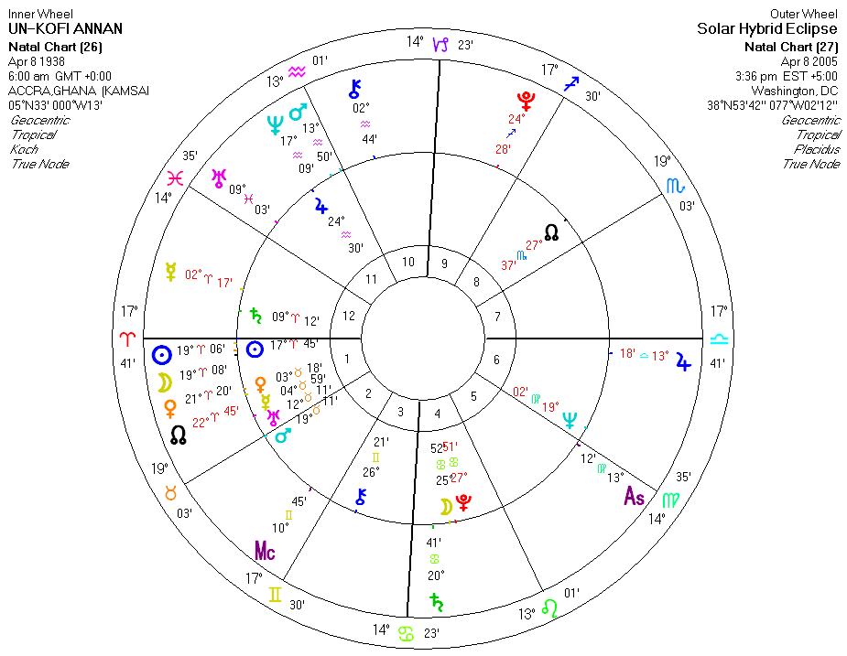

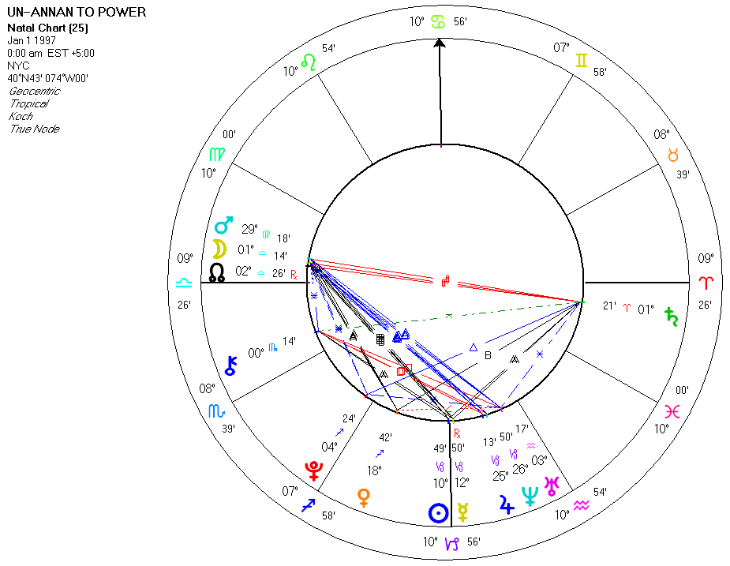

The oil-for-food program was established on October 13, 1997 and Benon Sevan was appointed as its head two days later, thus the charts are very similar. Note that the Suns in both charts were directly in the line of fire of the eclipse-node-Saturn affliction at 19-21 cardinal. The addition of these charts into the original analysis would have added a degree of certainty to the prediction.
The last chart is the solar chart for Benon Sevan. Sevan is now the target of a criminal probe by Manhattan District Attorney Robert Morgenthau. The investigation centers on allegations that Sevan not only steered U.N. aid contracts to favored bidders but also actually received compensation from the government of Saddam Hussein in the form of oil vouchers reportedly worth more than $1.5 million. Sevan denied any wrongdoing despite allegations by U.N. chief investigator Paul Volcker that the former U.N. official had engaged in "critical" lapses of judgment in his administration of the $60 billion aid program. Note that Paul Volcker was chosen by Annan to do the investigation and was not given subpoena power to obtain documents. Annan’s chief of staff began destroying documents on the day that the investigation was authorized. Annan claimed that Volcker’s final report cleared him, but Volcker, under media pressure, said that the report did not exonerate him. The Wall Street Journal called it, “the biggest fraud in the history of relief.” Because Saddam selected his customers, he sold oil to them below market value. The buyers re-sold these allocations at a big profit, kicking back payments to the dictator and his allies. The UN covered up the details of the transactions. Until the practice was made known, the UN even paid Sevan’s legal expenses out of the oil-for-food money. Annan would need to decide whether to lift Sevan's U.N. functional immunity if he is indicted by Morgenthau. Annan has pledged to remove such immunities if anyone is indicted, but has yet to carry through on that promise. In fact, Annan, through Volcker and the U.N.'s legal office, has sought to block U.S. congressional investigators from officially speaking to two Volcker investigators who recently quit. Meanwhile, Sevan has left his New York home and returned to his native Cyprus. The legal counsel also added that Sevan was in Cyprus to attend a memorial service for an aunt who died last year. It is the same aunt who died in a mysterious elevator accident in Cyprus at the same time she was under investigation by the Volcker panel. From 1999-2003, the aunt visited her nephew in NYC for a yearly summer holiday lasting a month. She also paid him $40,000 for each of the visits to "offset" expenses, according to Volcker. How an elderly pensioner with a declared income of approximately $600 monthly paid Sevan $40,000 for her yearly visits has yet to be explained. Those payments are also under investigation by New York City and federal prosecutors. Cyprus, it should be noted, has no extradition treaty with the United States.
With Pluto heading for Sevan’s Sun, setting off his t-square, he will take the fall for the UN.

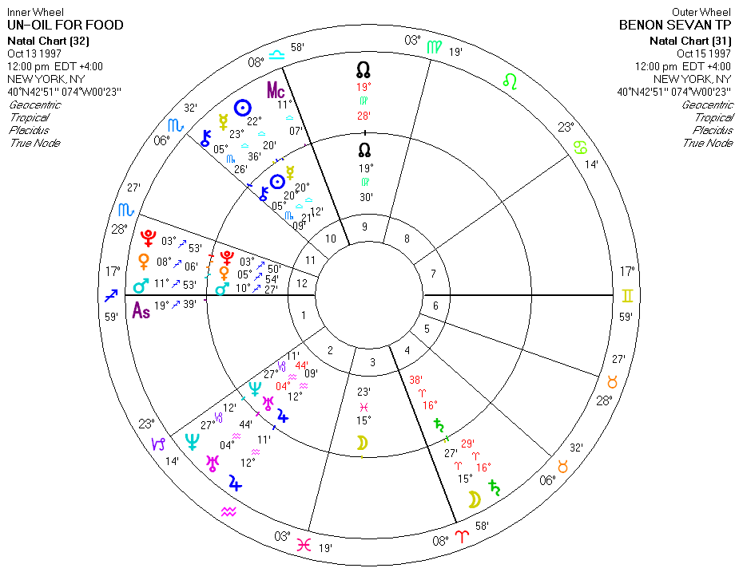

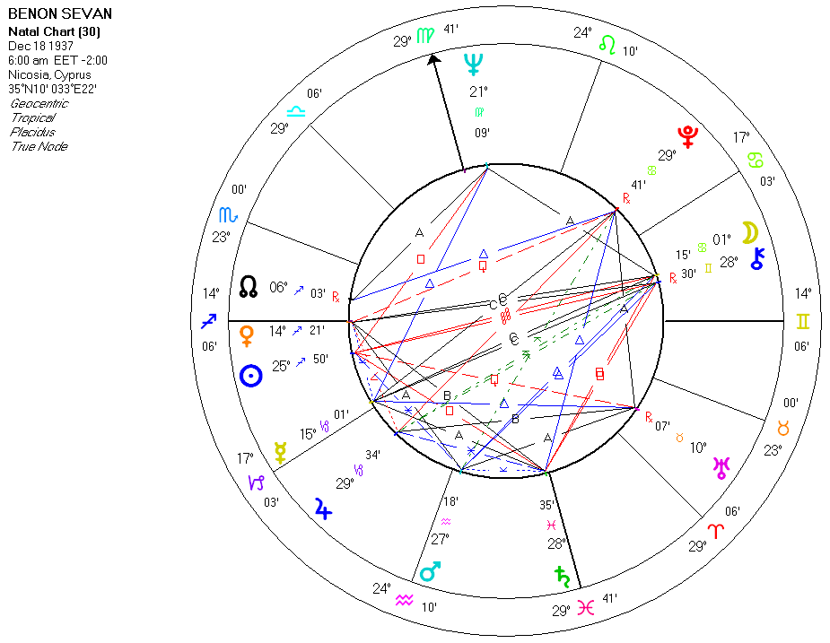

Copyright 2005 © Cycles Research, Ltd. USA

