4.-Tough Going and Rebellion in Afghanistan

This article also appeared in the Dell Horoscope 2005 Annual Forecast. It was written in May of 2004.

While we are on the subject of US fighting forces abroad, our attention falls upon Afghanistan (July 17, 1973). Saturn runs over the 24 Cancer Sun in the first half of the year while Pluto quincunxes the Sun. We find that the April 8 solar eclipse is on the natal Mars conjunction opposite Uranus. What an explosive combination! This is a repeat of an eclipse pattern from 1978 when an eclipse hit 17 Aries on April 7, and the Duad government was overthrown by the USSR-backed Taraki on April 27 of that year. The 1978 eclipse fell directly on the Afghan progressed Mars, which was directly opposite natal Uranus. Charles Jayne found that the progression of a natal aspect to exactitude was very powerful, and this is certainly true in this case. On top of that, transiting Pluto was in late Libra, near natal Uranus. The point is that the 2005 eclipse is tough, but not as severe as that of 1978.

On August 2, 1919, the British gave the Afghan people independence from British rule with the Sun and Neptune at 8 and 9 Leo. Saturn will reach these degrees later in the year, testing the people’s will for independence.

In the last quarter of the year, Saturn stations opposite the natal Moon. By converse secondary progression, we see that the Sun and Saturn are conjunct at 24 Gemini, a severe pairing. The transiting Pluto-Hades opposition will be on this conjunction all year and into 2006. Conditions will remain depressed. There are shortages and a lack of materials. The leadership is under pressure to alleviate these conditions, and will likely have to withstand a serious challenge in the spring. The people best take care because any overthrow of the government will likely lead to a more repressive regime.

There is a direct connection between this country, the USSR, and the current reign of terror in the world. The media has forgotten that the Soviets took about 25,000 young men with them when they withdrew form the country. These same men have come back to us as terrorists waving various banners. This crime against humanity goes unpunished.

Postscript- The key to this analysis was the computerized search that showed the Aril 2005 eclipse hitting the Mars-Uranus opposition in the 1973 chart. Note how the other Afghan charts were also affected. The key difference between this 2005 event being of lesser strength than the earlier events was that progressed Mars was not in exact aspect as it had been in the earlier event.
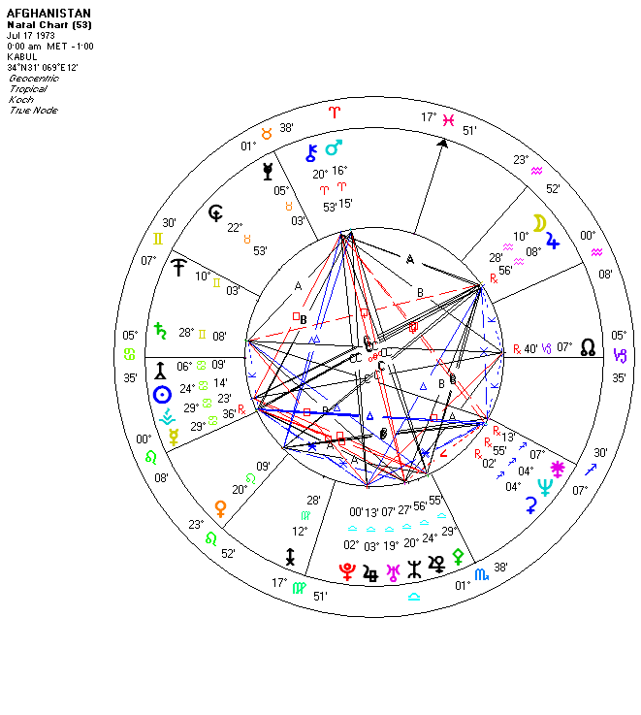
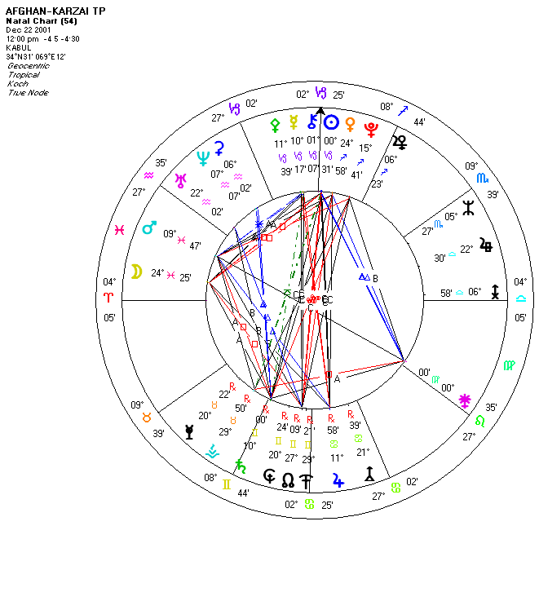

Copyright 2005 © Cycles Research, Ltd. USA

