The President’s Second Term in Office
By Bill Meridian
Copyright Cycles Research, Ltd. USA, March 2005

Summary

- The President faces much tougher times beginning in late Spring
- The most difficult time for the administration will run from late July through September
- The President’s safety is in jeopardy from April 2005 through February 2006
- The Vice President’s horoscope is very afflicted in late August-early September; his health may force him from office
- The harsh conditions in the President’s chart into 2006 likely reflect a more difficult economic situation.

Off to a Good Start

We have not looked at the prospects for President Bush since the successful prediction of his re-election. Inauguration day is traditionally set for 12 noon on January 20. Based upon his 2001 inauguration, I wrote that he would be a war president. This was due to the opposition of Mars to the ascendant in addition to its square to Mercury and Uranus in the 10th. In addition, there was a Moon-Pluto conjunction in the 8th house, an indication of loss of life. The 2005 chart is another tough one. Mars and Pluto are conjunct in the 8th house opposite Hades, a sign of continuing violence of the extreme type. Neptune is in mid-Aquarius square the ascendant, both of which tie into the world points at zero Aries, cloaking the administration in a cloud. Media bias continues to mislead public opinion. Saturn will oppose the Midheaven, and widely squares Jupiter on one side and the Node on the other. It appears that a weak economy or financial stress will bedevil the Republican administration. Saturn on the IC will also likely bring the helium-filled housing market back down to earth. Whereas this will be healthy for the economy, it will not be popular with homeowners.

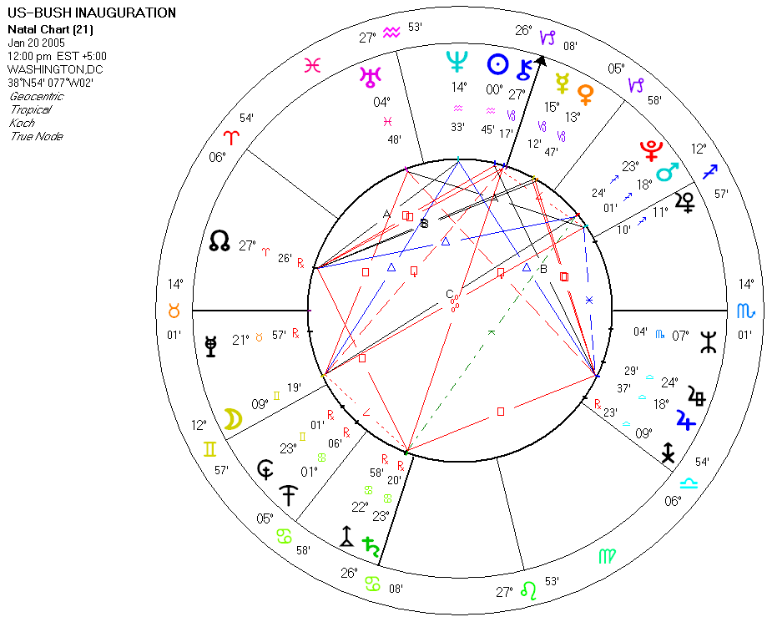

The President Begins 2005 in Good Form

Turning to his personal chart, we see a combination of influences from Pluto. It trines his Midheaven, an indication of acceptance by the masses. Most fall into line and follow his lead. His Jupiter return and the Node passing over his MC in February plus Jupiter sailing over his Moon in March ensure a good Q1 for the Chief Executive.

The April solar eclipse is at 19 Aries, roughly opposite the 21 Libra eclipse of last autumn. This past eclipse was the key determinant in the selection of Bush in the election. It fell between his Jupiter and his MC/IC axis, falling about 3 degrees from each. Eclipses are the most powerful phenomena in astrology, and the Jupiter/MC midpoint is a significators of popularity. So the eclipse at this degree was far more favorable than any occurrence in the challenger’s chart. The April eclipse is 2 degrees outside of this axis, but will likely energize this old October eclipse and midpoint to a degree. So there will likely be a recurrence of the support that lifted him to the Presidency.

The Clouds Roll In

The difficult influences would appear to have two possible manifestations: physical danger to the President and national economic stress. Pluto, the outermost planet, opposes his natal Uranus and his progressed MC and Node. In his converse progressed chart, we find Pluto opposing the ascendant. The September 2 Pluto station will put these energies at a peak. In June, the President will have Saturn passing over his Saturn again, and it will also square his progressed Venus, a sign of a drop in popularity. In September, Saturn will hit his ascendant, an important transit. Such returns are usually coincident with increased responsibility and burdens. Pluto, will however, continue to trine his MC, a sign that the powers that be will still support him.

Danger on the Horizon

The most important hit is the opposition of Uranus to his natal Mars (April 14) and to his progressed Sun (May 9). On June 14, Uranus makes its retrograde station, so these will not be the last hits to his Mars. The last hit will be next February, so he is entering a danger period. This is an explosive and a dangerous axis in his chart that includes hard aspects to Hades, Pluto, Saturn, Mercury, and the MC, as well as Mars. The semisquare to his MC guarantees that there are incendiary materials connected to his public reputation. Uranus and Mars will light the fuse. There may be revelations about past deeds or secrets that damage his reputation.

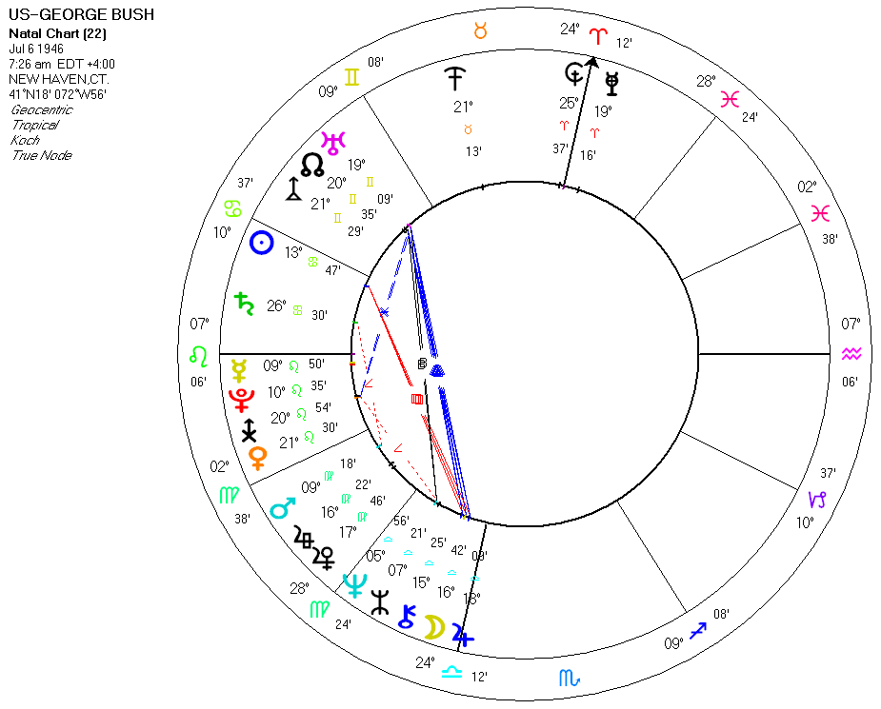

It is a fact that no war president has ever completed a second term in office. Will this be true this time? The Uranus-Mars opposition connected to the MC does suggest that the President is in danger. Saturn hitting the ascendant (in September) can coincide with job loss and moving for us ordinary folks. It could affect the President in the same way. There are some parallels with the Nixon administration. Both were Republicans, both were involved in controversial wars, and both faced economic uncertainties and rising commodity prices.

There is one more observation that we will amplify upon. There is a strong 84-year cycle generated by Uranus. Half of this cycle is 42 years or 180 degrees in motion. When Uranus was 180 degrees from its 2005 position, at 9-10 Virgo, it was directly on the progressed ascendant-natal Pluto conjunction and square to the progressed MC (11 Gemini) of John F. Kennedy in November of 1963. This observation derives from the fact that Uranus will be opposing President Bush’s Mars and progressed Sun from April 2005 to February 2006. This combination takes on extra strength because Mars rules the Bush Midheaven and the Sun rules the ascendant. His Mars axis connects to Hades, Pluto, Saturn, Mercury, and the MC by hard angles. This is a harsh combination that can bring physical harm.

Esoteric Technology’s Solar Fire software describes Uranus opposite Mars in the following way:

“The combination of Uranus and Mars can be explosive when placed in tension and these are the energies coming into your life under this transit. Events and other people are likely to act in an extreme and unpredictable fashion threatening your sense of security. You may feel that circumstances are poised to destroy all that you have achieved in your life, or that you are being prevented from achieving your goals right now. You may feel an inner rage and be tempted to break out. However, this is not a good idea. You are particularly accident prone during this transit and should avoid taking unnecessary risks. Your challenge is to re-evaluate your ambition discarding those which are unimportant, while calmly adhering to those which are close to your heart.”

To personalize this interpretation, I had an operation performed in 1977 with Uranus opposite my Mars. During the procedure, the anesthetic was improperly administered and my lungs stopped. The staff had failed to place the respirator in its appropriate place, and the surgeon had to use a manual technique until the equipment arrived. I do not recommend surgery under this aspect. Nor would I recommend any dangerous activity.

I think that we can safely say that the President will need to exercise great caution from April through the following February of 2006. Please note that his Mars-progressed Sun conjunction was already activated in 2003 when the eclipses and Mars stations occurred at 0 and 10 degrees of mutable signs, a contact that would fire the aggressive side of the nature. This coincided with the Iraqi conflict. The President was not in personal danger, except perhaps from the democrats. However, with Uranus now making the aspect to his Mars, matters work out unexpectedly.

Concern for the President’s safety leads along a logical path of inquiry as to the horoscopes of presidents and other leaders who have been harmed while in office. The assassination charts of Garfield (7/2/1881), McKinley (9/6/1901), John Kennedy (11/22/63), Robert Kennedy (6/5/68), and Martin Luther King (4/4/68) show much planetary activity at the degree spans 8 to 13 mutable or 19 to 21 mutable. The connections to the USA ascendant at 12 Sagittarius and Uranus at 9 Gemini are obvious. The national Mars at 21 Gemini square the USA Neptune at 22 Virgo stands out.
The Abraham Lincoln chart did not fit this pattern, nor did the Reagan assassination attempt horoscope. There is one less frequent, but interesting, connection. Neptune was at 15 Aquarius when Harrison died in office of natural causes, 15 Taurus when Garfield was assassinated and was at 15 Scorpio when JFK was shot; it is at 15 Aquarius now. (The transit to 15 Leo in the early 1920s did not produce any such event.) Uranus at 10 Pisces and Pluto at 22 Sagittarius, two unstable axes in the national chart active, confirm a danger period for the Chief Executive.

Mars frequently is a trigger, so we examine its positions:

October 1- transiting Mars retrograde at 23 Taurus
December 9- transiting Mars direct at 8 Taurus

November 18, 2005- progressed Pluto contraparallel the USA natal Mars at extremes in declination
July 20, 2006 USA progressed Mars stationary retrograde at 19 Libra

The October 1 station is on the natal USA Mars-Saturn midpoint. This degree, 23 Taurus, is also the degree of the 2000 Jupiter-Saturn conjunction and the degree of the Israeli Sun. This is followed by the progression of Pluto to the USA Mars in declination at extremes of north and south. Again, the latter is a progression and thereby generates conditions, which, in this case, are harsh and aggressive. Pluto is in hard aspect to his progressed Mars and Ascendant in October. Thus, October and November are tough months for the Chief Executive during which he will need to be on his guard while continuing to be a warrior. The December Mars station is square his progressed Mars-Pluto conjunction.

Lunations and eclipses can also act as triggers. The New Moon of September 3 is at 11 Virgo, on the President’s Mars. The December 1 New Moon is at 9 Sagittarius is square his Mars. Either lunation can act as a trigger. The October 17 lunar eclipse is on his Midheaven-Hades conjunction. This natal combination is quite obvious. The media and his opponents continually amplify his shortcomings and errors while downplaying his achievements. The last solar eclipse near this degree coincided with the Iraq prisoner uproar. This lunar eclipse is likely to produce unpleasant revelations in the six weeks on either side of the eclipse date. The event will not be as powerful as the Abu Graib solar eclipse.

A Rough Ride for VP Cheney

A logical next step is to analyze the VP’s chart. I do not detect any accession to the throne here, but the chart becomes very afflicted in the fall when Saturn sails into Leo. His natal chart has a Sun-Pluto opposition from 11 Aquarius to 3 Leo, and his progressed chart shows Mars opposing a Pluto-MC conjunction. Saturn hits the progressed opposition in late July-early August. Saturn stations opposite his natal Sun in November. On July 22, Saturn opposes the Sun in the inauguration chart, a significator of tough times. In some respects, the VP’s aspects are more difficult than those faced by the President. Given Mr. Cheney’s heart condition, the Saturn-Sun opposition could be life-threatening. The Saturn hits to the progressed Mars-Pluto suggest that he also faces harsh threats and potential danger. There is some possibility that he may have to step aside. The events of March 23-24 and October 1 are important dates during which these conditions may manifest.

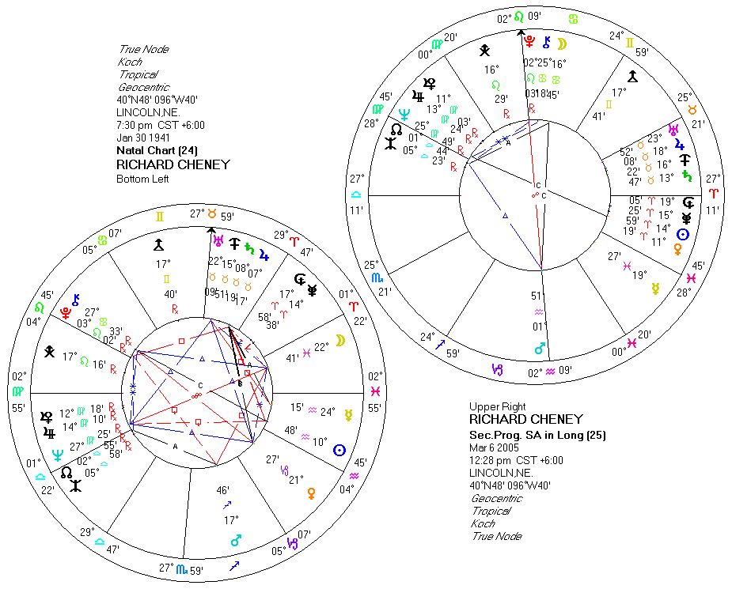

Economic Hardships Will Likely be a Weight

The second set of difficult aspects will likely coincide with a more difficult economy.
In November of 2006, President Bush’s progressed Sun will be 45 degrees from his Saturn. Hard aspects of the progressed Sun coincide with tough times. As Charles Jayne taught, the Sun has a diameter of about 1.5 degrees; therefore the appropriate orb to use is 9 months (9 months applying plus 9 months separating equals 18 months or 1.5 degrees by measuring one degree for one year). So, this aspect enters orb in February of 2006. Progressions usually breed conditions, rather than precipitating events.

From September 2005 through July 2006, Saturn will transit over the President’s ascendant, Mercury, and Pluto. This combination has been one of his strongest assets, having been activated by a lunation during his axis of evil speech. Saturn hitting the ascendant is one of the strongest of transits, usually coinciding with physical moves or changes in residence (for us normal folks).

What will be the result of these Saturnine effects? I think that the answer is potentially two-fold. The first is political. The democrats are stinging from their 2004 election defeat, and they are still hurling every imaginable stone at the administration. They are likely to increase their attacks, perhaps even trying to impeach the President.
The second possibility is more obvious and it is economic. The year after an election is usually bearish for the stock market because the president does not have to be concerned about being elected for another 4 years. Prior to the election, they do anything that they can to make the economy look robust, usually keeping interest rates low and credit readily available. (All periods of economic growth breed optimism, leading to the assumption of debt. After major periods of growth, there is usually too much debt outstanding that must be either paid off or defaulted upon.) After election, they usually cut back. This was not done after the 2000 election. In order to mitigate the effect of the internet bubble burst, the Federal Reserve greatly increased the money supply. Much of the excess credit went into real estate. Thus, the excessive borrowing and the inflation of the 1990s were not wrung out of the system in the first term. The amount of debt per capita is at an all-time high, and this is what holds the economy and the stock market back. Either, this debt will begin to default or the debt drag on the economy will become excessive. The harsh aspects in the President’s chart will likely coincide with a higher level of interest rates and bankruptcies.

If there is going to be a serious change in the Administration, such as the President or Vice President leaving office, it will likely occur in the August-September time period.

